Installation Manual

Step 1:

Double click **Setup.exe** then click Yes.

Step 2:

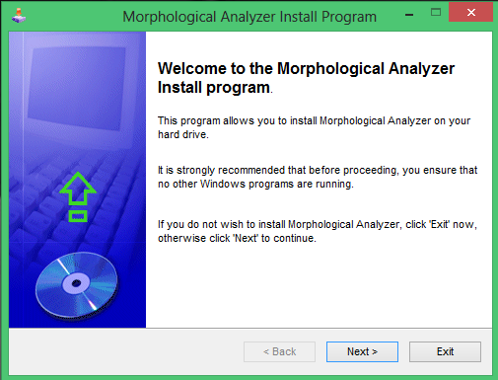

Click Next.

Step 3:

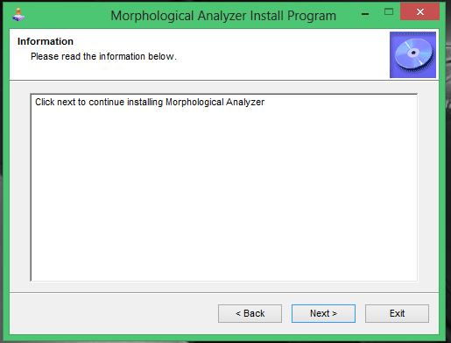

Click Next.

Step 4:

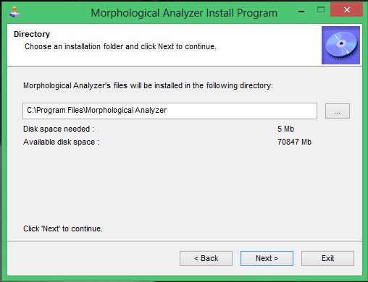

Click Next.

Step 5:

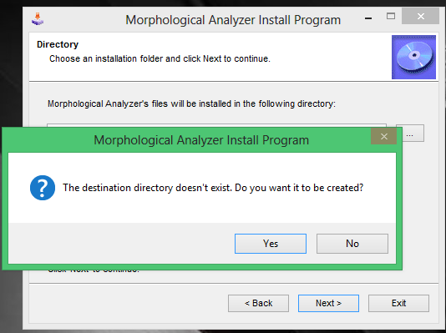

Click Yes.

Step 6:

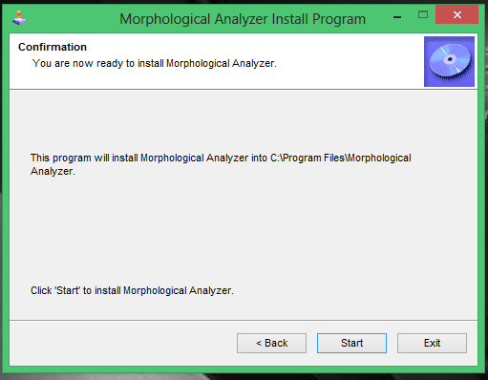

Click Start.

Step 7:

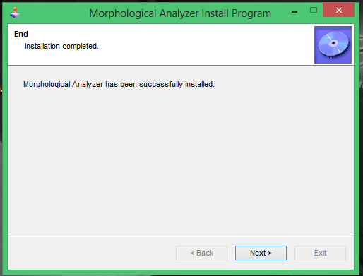

Click Next.

Step 8:

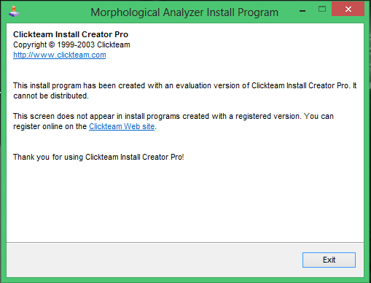

Click Exit.

**Finally**! You can now use Morphological Analyzer.

